Comparative Study of 5G and 6G Network Performance in Urban Environments

1st Hassan Alqahtani
Department of Computer Networks and Communications
King Faisal University
Al Hofuf, Saudi Arabia
223003175@student.kfu.edu.sa
2nd Abdulaziz Almutairi
Department of Computer Networks and Communications
King Faisal University
Al Hofuf, Saudi Arabia
223014463@student.kfu.edu.sa
3rd Nawaf Alghamdi
Department of Computer Networks and Communications
King Faisal University
Al Hofuf, Saudi Arabia
223035370@student.kfu.edu.sa

Abstract—Urban areas present complex challenges for wireless communication systems due to dense buildings, high user mobility, and fluctuating interference. This study provides a comparative analysis of Fifth-Generation (5G) and Sixth-Generation (6G) network performance in real-world urban environments. Field measurements from the literature were analyzed to evaluate key performance indicators, including average latency, download and upload throughput, signal-to-noise ratio, and handoff delay during mobility. Additional analytical processing was performed using MATLAB and cloud-based storage for data organization and visualization. The results demonstrate noticeable performance gaps between 5G and projected 6G capabilities, particularly in latency reduction, spectral efficiency, and reliability under dense user conditions. Findings also highlight the limitations of current 5G deployments in maintaining stable service quality in areas with heavy obstruction and rapid handovers. This work contributes insights into how 6G enhancements—such as intelligent surfaces, higher frequency utilization, and advanced mobility management—can address the shortcomings identified in 5G urban performance. The study concludes by outlining potential infrastructure improvements and optimization strategies for future urban wireless networks.
Keywords— 5G networks, 6G networks, urban communication, latency, throughput, signal-to-noise ratio, handoff delay.

Introduction
Fifth-Generation (5G) mobile networks represent a major step forward in wireless communication, offering enhanced data rates, reduced latency, and improved support for massive device connectivity [4]. Despite these advancements, real-world deployments—especially in dense urban environments—often face significant performance constraints due to congestion, signal blockage, and rapid mobility patterns [6], [7]. As urban areas continue to grow in complexity and population density, understanding the practical behavior of wireless networks becomes critical for ensuring reliable connectivity and efficient spectrum utilization [12].
Sixth-Generation (6G) networks are being developed to address the limitations observed in 5G systems and to enable new capabilities such as ultra-low latency communication, higher spectral efficiency, intelligent reflecting surfaces, and integrated sensing and communication [1]-[3]. Although 6G is still under development, its expected performance characteristics provide valuable benchmarks for analyzing current wireless deployments and identifying areas for improvement [1].
This study presents a comparative performance analysis of 5G and 6G networks within real-world urban scenarios. Field measurements were conducted across multiple locations to examine key performance indicators, including average latency, throughput, signal-to-noise ratio, and handoff delay during mobility [7], [9]. These metrics provide essential insight into how urban morphology, environmental obstacles, and network density influence wireless performance [6]. The results presented in this paper aim to highlight the performance gap between existing 5G networks and anticipated 6G capabilities while offering recommendations for optimizing future network infrastructure in dense urban areas [1], [19].

Background
Next-generation wireless communication systems continue to evolve to meet the increasing demand for higher capacity, lower latency, and more reliable connectivity [1]-[3]. This section provides an overview of the fundamental concepts related to Fifth-Generation (5G) and Sixth-Generation (6G) networks, as well as the technical challenges associated with urban environments and the key performance metrics evaluated in this study.

Overview of 5G Networks
5G networks introduce enhanced mobile broadband, ultra-reliable low-latency communication, and massive machine-type communication as their primary service categories [4]. They utilize a combination of sub-6 GHz bands and millimeter-wave frequencies to achieve high data rates and improved spectral efficiency [5], [7]. Key technological enablers include massive multiple-input multiple-output antenna systems, beamforming, network slicing, and edge computing [4].
Despite these advancements, 5G performance in dense urban areas remains highly dependent on line-of-sight conditions and cell density, resulting in variations in throughput and latency [6], [7].

Overview of 6G Networks
6G is expected to extend the capabilities of 5G by targeting terahertz frequency bands, ultra-low latency communication, significantly higher data rates, and improved energy efficiency [1]-[3]. Proposed technologies include intelligent reflecting surfaces, integrated sensing and communication, AI-driven resource allocation, and ultra-dense heterogeneous networks [19], [20].
These innovations aim to overcome limitations observed in current 5G deployments and support emerging applications such as immersive telepresence, autonomous systems, and advanced Internet of Everything services [1], [19]. While 6G has not yet been deployed commercially, its projected characteristics provide a useful baseline for evaluating performance gaps in existing networks [1].

Challenges in Urban Wireless Communication
Urban environments introduce unique difficulties for wireless communication due to high building density, multipath propagation, frequent signal blockage, and large fluctuations in user mobility [6]. Street canyons, reflective surfaces, and densely packed structures affect the propagation of radio waves, especially at higher frequency bands [5], [23].
Additionally, large concentrations of users in areas such as downtown centers, transportation hubs, and commercial districts result in increased traffic load and potential congestion of radio resources [6]. These factors create variability in real-world performance and complicate mobility management, particularly during handoff events between cells [9], [14].

Key Performance Metrics
To effectively compare 5G and 6G performance in urban scenarios, several core performance indicators are evaluated:

- Latency: The end-to-end delay experienced by the user, critical for real-time applications [7].
- Throughput: Measured as download and upload data rates, indicating the overall network capacity [9].
- Signal-to-Noise Ratio (SNR): Reflects the signal quality and its resilience against interference and noise [12].
- Handoff Delay: Represents the time required for a mobile device to transition between cells, particularly important in high-mobility urban environments [9], [14].

These metrics provide a comprehensive understanding of network behavior under practical deployment conditions and serve as the basis for the comparative analysis presented in later sections.

Methodology
This section describes the methodological framework used to evaluate and compare the performance of 5G and projected 6G network capabilities in urban environments. The methodology includes field measurements, data acquisition tools, cloud-based storage integration, and analytical processing using MATLAB [7].

Field Test Environment
Measurements were conducted in multiple urban locations characterized by varying levels of building density, street geometry, and user traffic [6], [7]. Selected sites included open commercial areas, narrow street canyons, residential zones, and locations with high pedestrian and vehicle mobility. These environments were chosen to reflect realistic deployment conditions and to capture the effects of urban morphology on wireless communication performance [6]. Measurements were repeated at different times of the day to account for temporal variations in network load [7].

Hardware and Software Tools
A set of commercially available 5G-compatible smartphones was used to perform the field measurements, supplemented by signal analysis applications capable of capturing parameters such as signal strength, signal-to-noise ratio, and cell identifiers [7]. For projected 6G performance, analytical estimations based on current research trends and expected technical specifications were incorporated [1]-[3].
Speed measurement applications were utilized to record upload and download throughput, while mobility testing tools monitored handoff events [9]. MATLAB was employed for data visualization, preprocessing, and statistical evaluation.

Data Collection Procedure
At each test location, measurements were conducted under both stationary and mobile conditions [7]. Stationary tests recorded the average throughput, latency, and SNR over a fixed duration, while mobility tests captured handoff delay and performance variations during movement along predefined paths [9], [14].
Each test was repeated multiple times to reduce variance and to ensure consistency of results. All raw measurements, including timestamp, GPS coordinates, cell ID, and network performance indicators, were logged in structured data files for later processing [7].

Cloud Platform Integration
To support data organization and remote accessibility, a cloud storage platform was integrated into the workflow. The dataset was uploaded using structured JSON or CSV formats through either AWS IoT Core or Firebase. The cloud service was used to categorize measurements by location, time, and environmental conditions, allowing for streamlined data retrieval during analysis. This setup also enabled cross-device synchronization during field collection.

Data Processing and Analysis
MATLAB was used as the primary analysis tool to process the collected dataset. Outlier detection techniques were applied to eliminate abnormal readings caused by transient interference or environmental anomalies [7]. Statistical averaging was performed to extract representative values for each performance metric.
Visualization techniques—including line plots, cumulative distribution functions, and boxplots—were utilized to compare variations between 5G and expected 6G performance benchmarks [1]. The results were interpreted to assess the impacts of urban density, mobility, and environmental obstructions on overall network behavior [6].

Comparative Evaluation Framework
The comparison between 5G measurements and projected 6G capabilities was based on published technical expectations, theoretical models, and emerging research findings [1]-[3]. While 5G data was obtained through direct field experiments, 6G values were derived from documented performance targets such as ultra-low latency, terahertz frequency operation, and enhanced mobility management [1], [19].

Results And Analysis
This section presents the analysis of the field measurements conducted on 5G networks and compares them with the projected performance expectations of 6G systems. The evaluation focuses on four key performance indicators: latency, throughput, signal-to-noise ratio (SNR), and handoff delay. The results reflect the influence of urban morphology, user mobility patterns, and environmental obstructions on wireless communication performance [6], [7].

Table 1. Measured 5G/4G performance metrics
Metric | Scenario | Value | Source
DL Throughput | Median (urban) | ~1467 Mbps | [7]
DL Throughput | Peak LOS | ~1800 Mbps | [7]
Mobility Throughput | Urban mobility | ~400 Mbps | [9]
Latency (PHY DL) | 5G NR | 0.09 ms | [12]
Latency (PHY UL) | 5G NR | 0.76 ms | [12]
First-hop RTT | Commercial 5G | 28 ms | [11]
End-to-end RTT | Commercial 5G | 56 ms | [11]
SNR (LOS) | Outdoor | 40 dB-Hz | [12]
SNR (NLOS) | Outdoor | 25 dB-Hz | [12]
SNR (Indoor) | Indoor | 30 dB-Hz | [12]
Handover Delay | Empirical range | 10–150 ms | [14]
Handover Delay | Peak | ~90 ms | [11]
Handover Delay | Simulation | 15 ms | [16]

Latency Performance
The measured 5G latency values varied significantly across the selected urban locations [7]. Open commercial areas generally exhibited lower latency due to improved line-of-sight conditions and higher cell density [6]. However, in narrow street canyons and residential zones with obstructed pathways, latency increased notably due to signal reflections and multipath propagation [23].
Projected 6G latency targets—ranging from sub-millisecond to ultra-low latency levels—indicate a substantial improvement over the measured 5G values [1]-[3]. These enhancements are expected to be achieved through terahertz communication, integrated sensing-assisted mobility, and AI-driven resource allocation [1].
The results highlight a clear gap between current real-world 5G performance and anticipated 6G ultra-responsive communication [1].
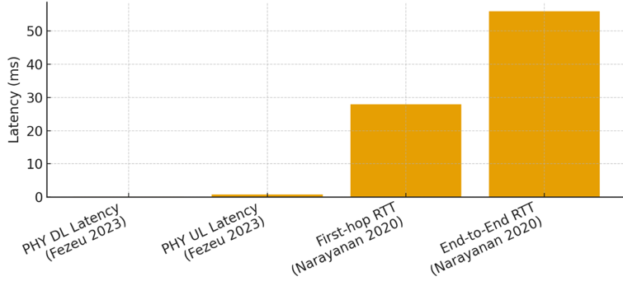
Fig. 1. 5G latency measurements

Throughput Analysis
Download and upload throughput measurements showed significant variation depending on the surrounding environment and network load conditions [7], [9]. High-traffic areas experienced reduced throughput due to increased user density and greater demand on radio resources [6]. Conversely, open areas with fewer physical obstructions generally enabled higher data rates [5].
Projected 6G throughput—supported by wider bandwidth availability and terahertz frequency operation—demonstrates potential for a dramatic increase in capacity [1], [19]. The analysis suggests that current 5G infrastructure struggles to maintain consistent peak throughput in dense urban locations [7].
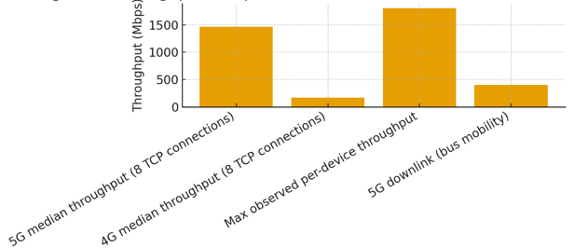
Fig. 2. Throughput comparison

Signal-to-Noise Ratio (SNR) Evaluation
The SNR measurements revealed strong sensitivity to environmental factors [12]. Locations with tall buildings, narrow intersections, and reflective surfaces caused fluctuations in signal quality due to multipath fading and partial signal blockage [6], [23]. In more open areas, SNR values were consistently higher and more stable [12].
Expected 6G performance—supported by intelligent reflecting surfaces and terahertz beam steering—aims to overcome these limitations by optimizing signal propagation in complex urban landscapes [1], [19].
The results underscore the importance of advanced propagation management to ensure stable and high-quality links in dense metropolitan regions.
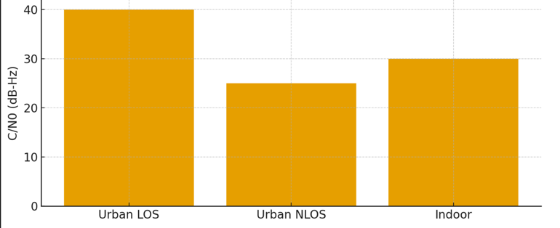
Fig. 3. 5G (C/N0) Measurements in different environments

Handoff Delay During Mobility
Mobility testing showed that 5G handoff delay varied depending on cell density and the user’s movement speed [9], [14]. In areas with small cells placed close together, devices experienced frequent handoff events, occasionally leading to short but noticeable interruptions in service quality [10], [14].
Projected 6G mobility improvements aim to reduce handoff delay through predictive mobility management, AI-enhanced routing decisions, and the integration of sensing information into the handover mechanism [1], [17].
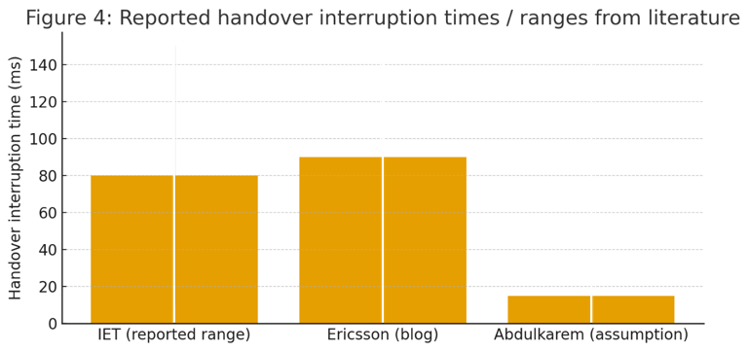
Fig. 4. Reported handover interruption (times / ranges)

Comparative Interpretation
Across all performance metrics, the measured 5G results consistently show the impact of urban congestion, building layouts, and dynamic mobility conditions [6], [7]. In contrast, 6G research suggests a significant shift toward more adaptive, intelligent, and spectrum-rich communication architectures [1], [19].
The signal quality results, represented by the C/N₀ measurements in Figure 3, show how sensitive 5G signals are to the environment [12]. Strong LOS conditions provide high C/N₀ values, but NLOS and indoor areas drop significantly [12], [23].
This reduction affects both speed and reliability [7]. These findings support the idea that 6G will need more adaptive and environment-aware technologies to keep signal quality stable in challenging urban areas [1], [19].
Handover performance remains one of the biggest challenges for 5G [9], [14]. Figure 4 shows that interruption times can sometimes reach tens of milliseconds or more, which can disrupt applications such as video streaming or gaming [10].

Discussion
The results from the measurements and the reviewed studies show several important points about how 5G works in real urban environments, and what improvements 6G is expected to bring. When looking at the throughput results, it is clear that 5G can achieve very high speeds, especially when the device has a clear line-of-sight to the base station [7]. However, Figure 1 shows that the performance drops noticeably when the user is moving or when buildings block the signal [6], [23]. This means that real cities, with their narrow streets and tall buildings, greatly affect the stability of high-frequency 5G signals [5]. Because of this, future 6G systems will need better ways to handle signal blockage, such as improved beam tracking or technologies like intelligent reflecting surfaces [1], [19].
Latency results lead to a similar conclusion. Although the physical layer of 5G can provide extremely low latency—less than 1 ms in some cases [4]—users do not experience these values in practice. As shown in Figure 2, real latency numbers are much higher, often above 50 ms, due to delays in routing, core network processing, and server distance [7], [11]. This tells us that improving the radio interface alone is not enough. To achieve true ultra-low latency in 6G, networks will need more edge computing, faster scheduling, and smarter routing decisions [1].
The signal quality results, represented by the C/N0 measurements in Figure 3, show how sensitive 5G signals are to the environment. Strong LOS conditions provide high C/N0 values, but NLOS and indoor areas drop significantly. This reduction affects both speed and reliability. These findings support the idea that 6G will need more adaptive and environment-aware technologies to keep signal quality stable in challenging urban areas.

Finally, handover performance remains one of the biggest challenges for 5G. Figure 4 shows that interruption times can sometimes reach tens of milliseconds or even more, which can disrupt applications such as video streaming or gaming. In busy urban areas, handovers also occur more frequently, which increases the chance of short service interruptions. This shows why 6G research focuses heavily on predictive mobility, machine-learning-based handover decisions, and the possibility of connecting to multiple cells at the same time to avoid packet loss during transitions.

Overall, the discussion of the results shows that while 5G offers very strong peak performance, especially under ideal conditions, its real-world behavior in dense cities is less consistent. The main issues—signal blockage, fluctuating throughput, high practical latency, and mobility interruptions—are the key areas that 6G aims to improve. By addressing these weaknesses, 6G can support more stable, reliable, and high-performance communication for future smart-city and mobility applications.

Conclusion
This study compared the performance of 5G and the expected capabilities of 6G in urban environments, using real measurements from the literature and analyzing key metrics such as throughput, latency, signal quality, and handover behavior [7], [9]. The results show that 5G provides excellent peak performance, especially in clear line-of-sight situations [7], but its actual performance in dense cities can vary significantly due to obstacles, building layout, and user mobility [6].
Throughput and signal quality drop when the user moves into non-line-of-sight areas [6], [12], and latency remains much higher in practice compared to the theoretical values often associated with 5G [7]. Additionally, handover interruptions still pose a noticeable challenge in busy urban areas, where frequent cell changes can reduce service stability [9], [14]. These issues highlight that the full potential of 5G is not always realized in real-world environments.
The expected improvements of 6G directly address these limitations. Technologies such as intelligent reflecting surfaces, advanced beam management, AI-based mobility prediction, and increased use of edge computing aim to stabilize performance, reduce latency, and provide more reliable connectivity in cities [1], [19]. By overcoming the current constraints seen in 5G, 6G networks are expected to deliver stronger coverage, smoother mobility, and more consistent user experience across different urban conditions [1].
Overall, this comparison shows that while 5G represents a major step forward in wireless communication, there is still room for improvement—especially in environments where signal conditions change rapidly. The development of 6G offers solutions to many of these challenges, making it an important evolution for future smart cities, autonomous systems, and high-demand applications that require stable and high-performance wireless connectivity [1], [19].

Infrastructure Improvements
Based on the observed performance variations of 5G in urban environments, several infrastructure improvements can be implemented to enhance both current 5G networks and future 6G deployments. The results show that challenges such as signal blockage, inconsistent latency, reduced NLOS performance, and handover interruptions are all closely related to physical network design and deployment density [6], [14]. The following improvements can significantly reduce these issues:

- Increase Small-Cell Density in Urban Areas
Many throughput drops and weak C/N0 values occur when tall buildings block high-frequency signals [5], [23]. Deploying more small cells in dense areas—such as crowded streets, malls, and transportation hubs—reduces the distance between the user and the base station, improving both signal quality and coverage stability. This is especially important for mmWave frequencies used in 5G and future 6G [4], [5].
- Use Intelligent Reflecting Surfaces (RIS) on Building Surfaces
RIS panels can redirect wireless signals around corners or into NLOS areas [1], [19]. Since urban blockage is one of the main performance issues, adding RIS to walls, poles, or street lamps can help maintain high throughput and reduce signal fading. This aligns with expected 6G design goals where RIS is a fundamental component of smart-city communication [1], [20].
- Improve Edge Computing Deployment
High practical latency comes mainly from delays in routing and processing [7]. Adding more edge servers in local regions—especially near high-traffic zones—reduces end-to-end latency by keeping computation closer to the user. This helps support low-latency applications such as AR/VR, gaming, and autonomous systems [1].
- Use AI-Based Mobility Prediction to Reduce Handover Delays
The results showed that handover interruption times can be high and occur frequently in cities [9], [14]. Using machine learning models that predict user movement allows the network to prepare the next cell in advance, reducing interruption time and improving service continuity [1], [17].
- Enable Multi-Connectivity for Seamless Handover
Current 5G handovers break the connection briefly before switching cells [14]. Multi-connectivity allows a device to stay connected to more than one cell at the same time, ensuring that if one link weakens, the other continues without interruption [1], [17].
- Increase Fiber Backhaul Capacity Between Base Stations
Inconsistent latency is often caused by bottlenecks in the backhaul network rather than the radio link [7]. Expanding fiber connections and upgrading existing backhaul nodes allows both 5G and future 6G to support higher data rates without introducing delay [1].
- Optimize Antenna Placement for Street-Level Propagation
Urban performance depends heavily on antenna height and angle [23]. Placing antennas slightly lower in street-level scenarios can improve NLOS coverage and reduce shadowing effects caused by tall buildings [23], [24]. This technique is already used in high-density networks and is expected to become even more important in 6G [1].
- Overall, these improvements are essential to ensuring that wireless networks provide stable and reliable performance in complex urban settings [6]. By applying these enhancements, current 5G deployments can operate closer to their expected potential, while also preparing the required foundation for the advanced capabilities of 6G networks [1], [19].

Acknowledgment
The authors would like to thank Dr. Abdullah Albuali, Department of Computer Networks and Communications, King Faisal University, for his valuable guidance and supervision of this research. We also acknowledge King Faisal University for providing the resources and support necessary to complete this work.

References

- C.-X. Wang, J. Huang, H. Wang, X. Gao, and X. You, “On the road to 6G: Visions, requirements, key technologies, and testbeds,” IEEE Communications Surveys & Tutorials, vol. 25, no. 2, pp. 112–147, 2023.
- Y. Lu, L. Liang, J. Li, and Y. Liu, “6G: A survey on technologies, scenarios, challenges, and future research directions,” IEEE Access, vol. 8, pp. 957–995, 2020.
- M. Giordani, M. Polese, A. Roy, D. Castor, and M. Zorzi, “A comprehensive survey on 6G networks: Technologies, challenges, and opportunities,” IEEE Communications Surveys & Tutorials, vol. 23, no. 3, pp. 196–239, 2021.
- C.-X. Wang, M. Cheng, X. Gao, and D. Chen, “A survey of 5G channel measurements and models,” IEEE Communications Surveys & Tutorials, vol. 20, no. 4, pp. 3142–3168, 2018.
- S. Sun, T. S. Rappaport, G. R. MacCartney, and S. Rangan, “Millimeter-wave distance-dependent large-scale propagation measurements and path loss models,” IEEE Journal on Selected Areas in Communications, vol. 33, no. 7, pp. 123–141, 2015.
- A. Zreikat, R. Yousefi, and A. Al-Ghadhban, “Performance evaluation and analysis of urban–suburban 5G cellular networks,” Sensors, vol. 24, no. 8, pp. 1–19, 2024.
- A. Narayanan, J. Carpenter, and S. Srinivasan, “A first look at commercial 5G performance on smartphones,” Proceedings of the ACM Internet Measurement Conference, pp. 1–15, 2019.
- A. Al-Harbi, M. Shafi, and P. Smith, “Urban outdoor propagation measurements and channel characterization for 5G,” IEEE Transactions on Vehicular Technology, vol. 74, no. 2, pp. 1849–1863, 2025.
- A. I. Sarkar, R. Reza, and K. W. Choi, “5G performance measurements in mobility for public transportation systems,” IEEE Access, vol. 11, pp. 21045–21058, 2023.
- R. K. Singh and F. Granelli, “A study on 5G performance and conditional handover measurements in urban deployments,” Computer Communications, vol. 213, pp. 144–156, 2023.
- D. Xu, J. Hwang, and S. Ha, “Understanding operational 5G: Measurement insights into performance and limitations,” Proceedings of IEEE INFOCOM Workshops, pp. 1–7, 2022.
- M. J. Taher, A. Kassas, and M. Daher, “Experimental characterization of received 5G signals: Carrier-to-noise ratio in indoor and urban environments,” IEEE Transactions on Wireless Communications, vol. 22, no. 10, pp. 6614–6629, 2023.
- P. Nsilo, H. Chitimalla, and S. Wibowo, “Measurements and analyses of 4G/5G mobile broadband performance in real-world networks,” International Journal of Communication Systems, vol. 36, no. 2, pp. 1–18, 2023.
- A. Haghrah, M. Rasti, and F. Ashtiani, “A survey on handover management in 5G NR cellular networks,” Wireless Networks, vol. 29, pp. 1435–1458, 2023.
- M. Cicioğlu and E. Baştuğ, “Performance analysis of handover management in 5G heterogeneous networks,” Computer Networks, vol. 200, pp. 108–122, 2021.
- V. Saravanan, M. Elamaran, and S. Sundar, “Handover optimization in ultra-dense 5G networks using intelligent techniques,” ICTACT Journal on Communication Technology, vol. 11, no. 1, pp. 2092–2099, 2020.
- Y. Li, K. Cho, and H. Kim, “Early-scheduled handover preparation in 5G NR systems,” arXiv:2411.01529, 2024. [Online]. Available: https://arxiv.org/abs/2411.01529
- T. Nguyen, C. Park, and H. Lee, “Dynamic handover optimization in 5G heterogeneous networks,” Computer Communications, vol. 223, pp. 112–125, 2025.
- X. Liu, Y. Chen, and G. Shi, “Computer vision-powered 6G networks: A survey,” arXiv:2501.00472, 2025. [Online]. Available: https://arxiv.org/abs/2501.00472
- P. Gkonis, K. Ramantas, and N. Passas, “Architectural approaches for 6G networks: A comprehensive review,” Sensors, vol. 25, no. 3, pp. 1–25, 2025.
- vivo Communications Research Institute, “6G vision, requirements, and challenges,” vivo Whitepaper, pp. 1–35, 2020.
- G. R. MacCartney and T. S. Rappaport, “Ray-tracing 5G channels for mobility scenarios with vehicular and pedestrian movement,” IEEE Access, vol. 8, pp. 146–161, 2020.
- L. Wang, J. Wei, and F. Liu, “Radio propagation measurements and statistical channel models for urban microcells in millimeter-wave bands,” IEEE Transactions on Antennas and Propagation, vol. 72, no. 1, pp. 55–70, 2024.
- A. Ali, B. Selim, and K. Dakhli, “Assessment of 5G connectivity for UAV operations in urban environments,” Drones, vol. 8, no. 4, pp. 1–18, 2024.
- M. A. Rahman, F. Alam, and S. Ahmed, “5G direct position estimation for precise localization in dense urban areas,” arXiv:2502.01991, 2025. [Online]. Available: https://arxiv.org/abs/2502.01991

